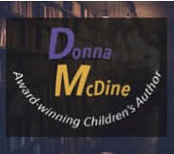

The Story Behind the Book

By Donna M. McDine

Thank you for subscriber to my newsletter, Write What Inspires You! It is my mission to bring to you each month authors and illustrators for you to get to know and share a bit of my road to publication journey each month.

As my thank you to you in becoming an opt-in subscriber I hope you enjoy *The Story Behind the Book* e-book. One of the most popular questions children ask me during author visits and book fairs is “How do you come up with your ideas?” My e-book answers this popular question.

Hope you and your young muse enjoy! Keep reading!

Best wishes,

*Donna McDine*

Multi Award-winning Children's Author

Ignite curiosity in your child through reading!

Website: [www.donnamcdine.com](http://www.donnamcdine.com/)

Email: [donna@donnamcdine.com](mailto:donna@donnamcdine.com)

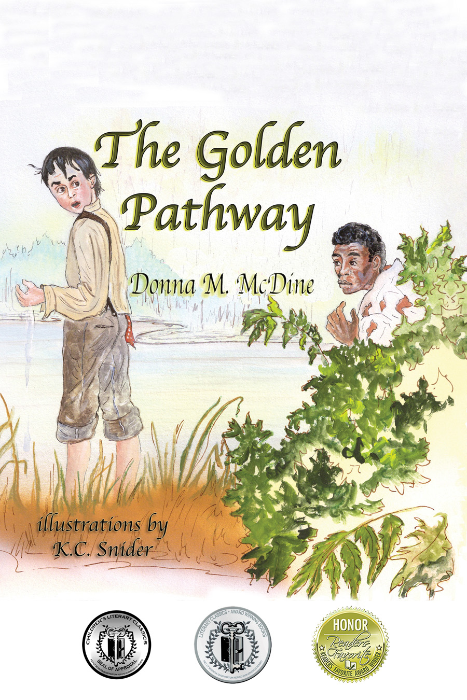 [](http://donnamcdine.com/donnasbooks.html)

I have always had a fascination for American History and living in the historical hamlet of Tappan, New York is a constant reminder of the rich history of our country. And when the opportunity arose at the end of the Institute of Children’s Literature Writing for Children and Teenagers course to create an outline for a book idea I naturally gravitated toward the Underground Railroad.

I initially visited my local library and researched both children’s and adult books on the Underground Railroad. The wealth of information was endless, but once I focused on the central character being the son of a slave owner the story flowed. From start to finish after research it took about a year to edit and fine-tune the manuscript to feel confident enough to submit to the Writer’s Digest Writing Competition. After placing 12th in the Children’s/Young Adult category I then met Lynda Burch of Guardian Angel Publishing and submitted. After several more edits and expansion of the story, Ms. Burch offered me my first children’s book contract, adding about another two years to the process. It may seem like a long time, but it’s all worth it.

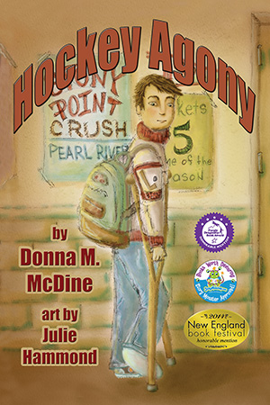 [](http://donnamcdine.com/donnasbooks.html)

Throughout the years of watching my nieces, nephews and my own children compete in one sport or another it became concerning how some coaches, teammates and parents thought the almighty win was the most important outcome to a game. Sometimes even encouraging the children to cheat or inflict bodily harm to an opponent to win. In today’s day and age it’s more important than ever to teach our children that “honesty is the best policy” and good sportsmanship is imperative. It may sound like a cliché to some, but without honesty and staying to true one’s self we would all self-destruct.

I used the backdrop of hockey since several of my nephews and a niece are avid hockey players and I wanted to pay tribute to them since I chose different names for the characters.

For Hockey Agony, even though the story honesty and peer pressure is based around the sport hockey, it’s important to overcome peer pressure in any circumstance that presents itself.

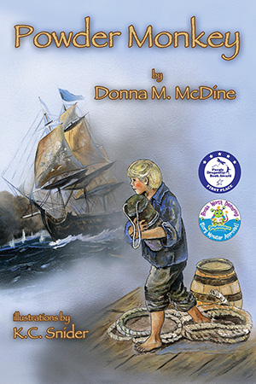 [](http://donnamcdine.com/donnasbooks.html)

Powder Monkey was an initial manuscript I wrote and submitted to a different publisher that put out a request for manuscripts for the late 1700's to 1800's time period, specifically dealing with the Royal Navy. Being a lover of everything historical fiction I jumped at the opportunity. They turned it down, but after several rounds of edits with Guardian Angel Publishing Powder Monkey was awarded an acceptance.

The Royal Navy Press Gangs is incredibly fascinating to me, especially since the Press Gangs would kidnap boys as young as 12 years of age and force them to work on the ships. Appalling, but incredible for a writer to uncover. The story idea flowed as well as the characters making for a journey like non-other.

Often times I find knowing when to stop the research the most difficult. I never "throw out" my research even if it all does not make it into the current work-in-progress...one never knows when it will come in handy for a new manuscript. Here's to the next bit of research taking a life of it's own on!

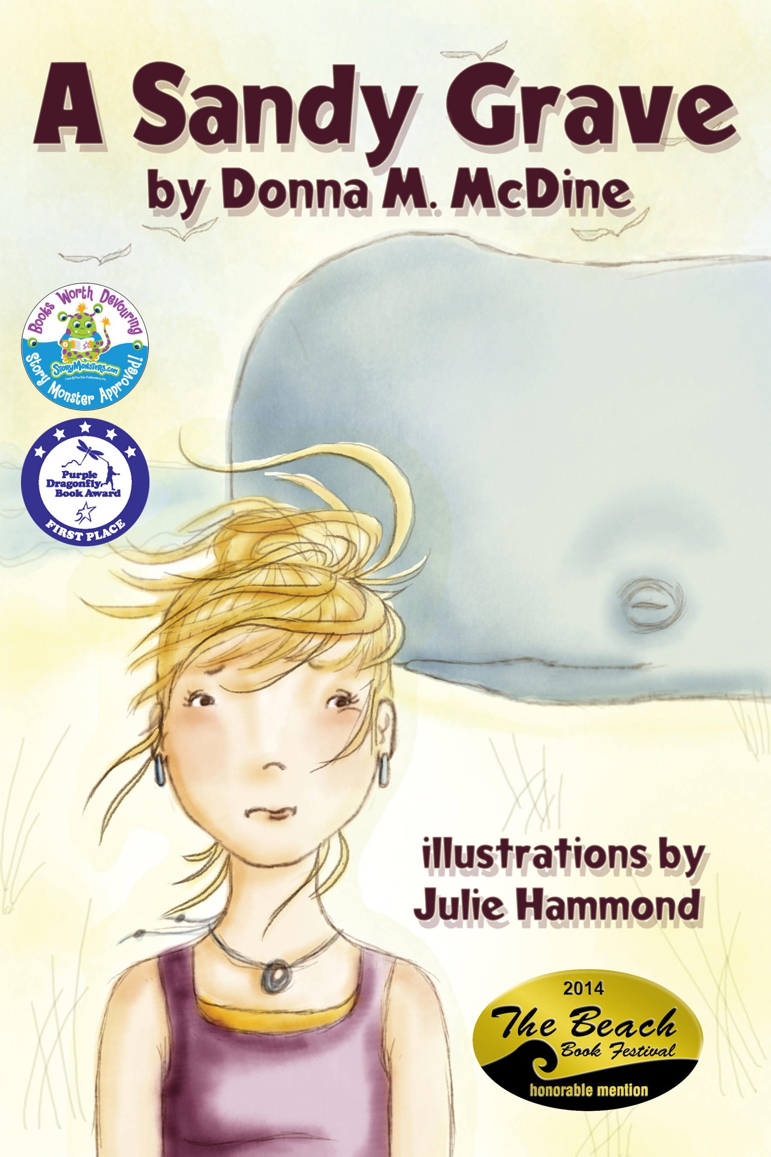 [](http://donnamcdine.com/donnasbooks.html)

Beyond the enjoyment of a beach vacation I never gave much thought to marine life. Sure we’ve gone on the typical whale or dolphin watching tours and were always delighted to see these creatures come up out of the ocean. But I never truly paid attention to what some humans do to marine life, until the day I read a news article about a dead whale that washed up on shore of a California beach. What fascinated me about this article was the police needed to guard the whale, until the local marine biology institute could arrive to determine what the whale died from. The reasoning for guarding astounded me. Apparently, poachers would take the opportunity to steal the whale’s teeth to sell for artists to create scrimshaw on the teeth and then sell for a profit.

This particular article pumped up my creative writing juices and before I knew it, I was researching marine biology, Endangered Species Act, and the Mammal Protection Act. Then came the creation of the fictional storyline and characters. Once I knew how I wanted the characters to be instrumental in propelling the story along with my research, the two blended into a beach adventure with a learning aspect without preaching to the reader. Hence, A Sandy Grave was born. The title was created from points in the article and research.

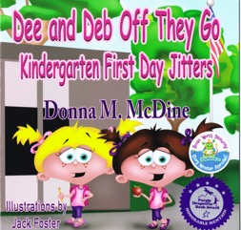 [](http://donnamcdine.com/donnasbooks.html)

My lifelong adventures with my fraternal twin sister inspired me to write about the first time we were separated within the classroom. At that time over 50 years ago, children typically did not attend a structured classroom until kindergarten. So to be separated from the comfort of my fraternal twin sister in a different kindergarten class was frightening for me at the time. The story of Dee and Deb is in tribute to our experience early on in life.

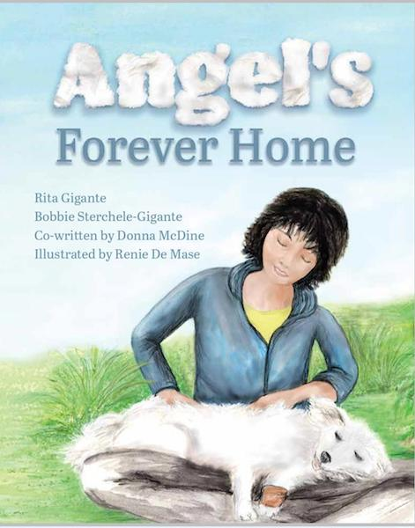 [](http://donnamcdine.com/donnasbooks.html)

Long before Angel leapt off the pages of [*Angel’s Forever Home*](https://www.amazon.com/Angels-Forever-Home-Rita-Gigante/dp/1643071211/ref=sr_1_2?dchild=1&keywords=Angel%27s+Forever+Home&qid=1585673027&sr=8-2), Angel’s true story began in the aftermath of the Chilean earthquake when a dog rescuer saved him. Transported to the United States his dog rescuer began making contact with potential adoptive families. Unfortunately, many could not take on the expense of a badly injured dog. Until the day Rita Gigante was introduced to Angel. Immediately falling in love with Angel, Rita brought her wife Bobbie Sterchele-Gigante back the next day to meet Angel. Bobbie too, felt her heart fill with overwhelming love for Angel and they adopted him.

For years, Rita and Bobbie chatted about creating a children’s book telling of Angel’s story for children to enjoy and to learn that each of our differences is what brings us together. While the book idea was put on the backburner for many years, new friendships developed and Rita intuitively knew this was now the time to invite Renie De Mase and myself in for a collaboration project.

I had the privilege of meeting Rita and Bobbie about ten years ago at a local psychic fair event they were hosting and we have remained connected ever since. So when Rita presented this opportunity for me to co-write and Renie to illustrate Angel’s story we both jumped at the chance immediately.

You may be thinking by now, wow four people collaborating on one book project, it must have been difficult with everyone’s opinions. It was quite the contrary. Our give and take during our brainstorming and writing sessions went swimmingly. Of course, the three of us left Renie to her expertise in illustrating once we discussed our visions.

We are beyond pleased of the finished book product and we all hope you enjoy Angel’s story as well.

Thank you for joining me. I hope you have enjoyed *The Story Behind the Book*.

I offer FREE downloads of activities and educator guides at my website [www.donnamcdine.com](http://www.donnamcdine.com) for further enjoyment.

Please feel free to contact me at [donna@donnamcdine.com](mailto:donna@donnamcdine.com) with any questions you may have. I enjoy the interaction with my readers. Thank you!

**About me:** I am a multi award-winning children's author, Honorable Mention in the 77th and two Honorable Mentions in the 78th Annual *Writer’s Digest* Writing Competitions, *Angel’s Forever Home* ~ 2019 Purple Dragonfly Honorable Mention Picture Books, *Dee & Deb Off They Go Kindergarten First Day Jitters* ~ 2016 Purple Dragonfly Honorable Mention Picture Books Five and Under and Story Monster Approved, *A Sandy Grave* ~ Purple Dragonfly 2014 Award First Place Picture Books 6+, Story Monster Approved and Beach Book Festival Honorable Mention 2014, *Hockey Agony* ~ Story Monster Approved, *Powder Monkey* ~ Story Monster Approved, *The Golden Pathway* ~ **Literary Classics Silver Award & Seal of Approval Recipient** Picture Book Early Reader, Readers Favorite 2012 International Book Awards Honorable Mention, Global eBook Awards Finalist **Children’s Picture Book Fiction,** and Preditors & Editors Readers Poll 2010 Top Ten Children’s Books.

I am a member of the Society of Children’s Book Writers & Illustrators (SCBWI), New York State Reading Association and Family Reading Partnership.